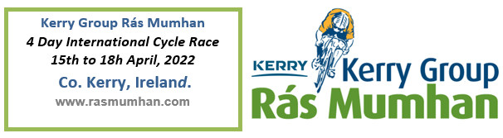
Open to the following categories A+, A1, A2, A3 & Juniors
(Senior Teams of 5 # Riders & Juniors Teams of 6 # Riders)
I understand and agree that I participate in this race entirely at my own risk, that I must rely on my own ability in dealing with all hazards, and that I must ride in a manner which is safe for myself and all others. I am aware that when riding on a public highway the function of the marshals is only to indicate direction and that I must decide whether the movement is safe. I agree that no liability whatsoever shall attach to the promoter, promoting club, race sponsor, Cycling Ireland or any of its regional committees or any race official or member of Cycling Ireland, or members of the promoting club in respect of any injury, loss or damage suffered by me in or by reason of the race, however caused.
Please complete the following section in full – Entry Fee €500.00
Team Name:
Team Manager Name & Tel No:
 | Name | UCI Number | Category
Rider # 1
Rider # 2
Rider # 3
Rider # 4
Rider # 5
Rider # 6

Closing Date for Expression of Entry: Friday 18. Feb. 2022
50% Entry Fee (€250.00) required to secure place – if team place is not available the 50% Entry Fee will be refunded. Team place will be confirmed by return of email on or before 04.Mar.2022
Closing Date for final Team Entry: 04. April.2022
The remaining 50% Entry Fee (€250.00) is required to retain final place, the Entry fee at this stage is non-refunded.
---------------------------------------------------------------------------------------------------------------------------
Bank Transfer to Cycling Munster: IBAN IE43BOFI90437653657495
Please use Team Name as Payment Reference when paying online.

Please email Entry Form to: kgrm2022@gmail.com
Please use Team Name as Email Subject when emailing this entry form

Tel. No: 00353 863102761 E-mail: kgrm2022@gmail.com

