Confirmation of Regulations on Race Number placement and Number Pockets

The Technical Working Group would like to remind all riders of the UCI regulations, that we operate under for the placement of numbers in races – in the past years number pockets have become popular however these have presented problems for Commissaires, Photo Finish, Judges, Race spectators and followers.

Some examples are given below – and this is also happening with events in Ireland, and proving very difficult to identify riders during the race and in the results.

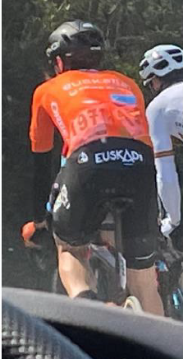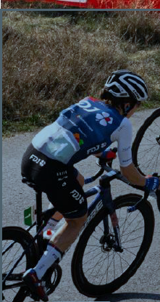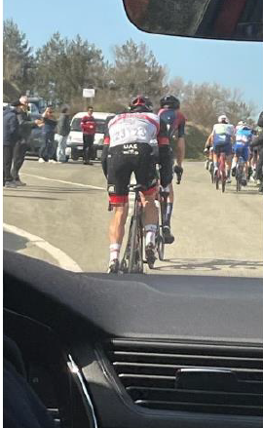

So to clarify what is allowed for the 2023 season – the following table applies.
This indicates the use of number pockets in only permitted for the following

Road Events – Only Time Trials
Track Events – Individual & Team Pursuit, Time Trial & Team Sprint
Cyclocross – Not allowed.

Clarification Table
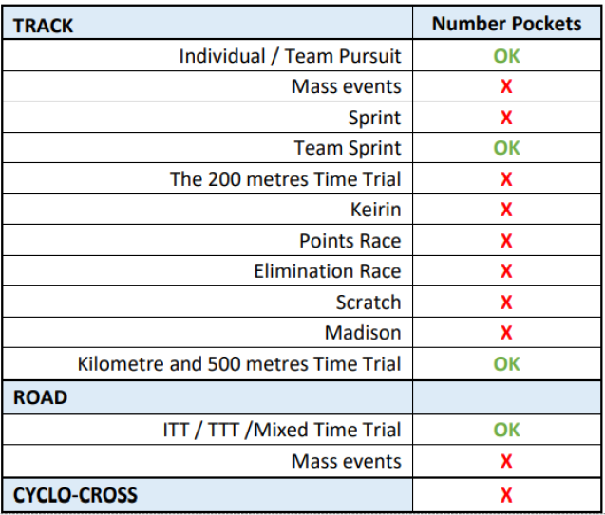

Riders may be asked by Commissaires to adjust numbers before the start if they notice it – but the responsibility is on the riders to ensure compliance – if you cannot be identified you may be removed from the race results.

Should you have any questions on these changes please contact me at paul.watson@cyclingireland.ie

Paul Watson
Technical Consultant Cycling Ireland
07.03.2023

