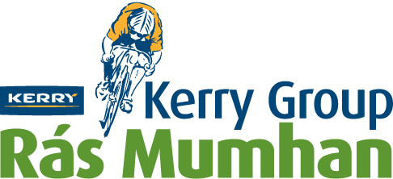
Kerry Group Rás Mumhan

4-DAY INTERNATIONAL STAGE RACE
March 30th to April 2nd 2018 www.rasmumhan.com

Open to the following categories A+*, A1, A2, A3
*A+ riders are members of a UCI registered team. Entry to the race of riders who are members of a UCI registered team is regulated by Cycling Ireland and as described in the Race Regulations.

Entry Form
I understand and agree that I participate in this race entirely at my own risk, that I must rely on my own ability in dealing with all hazards, and that I must ride in a manner which is safe for myself and all others. I am aware that when riding on a public highway the function of the marshals is only to indicate direction and that I must decide whether the movement is safe. I agree that no liability whatsoever shall attach to the promoter, promoting club, race sponsor, Cycling Ireland or any of its regional committees or any race official or member of Cycling Ireland, or members of the promoting club in respect of any injury, loss or damage suffered by me in or by reason of the race, however caused.

Please complete the following section using Block Capital Letters

Team/Club Name: _________________________________________

Name: UCI Code: Category:
Rider 1 _____________________ __________________ _______
Rider 2 _____________________ __________________ _______
Rider 3 _____________________ __________________ _______
Rider 4 _____________________ __________________ _______
Rider 5 _____________________ __________________ _______

Manager ____________________ __________________

Address _____________________________________________________

Tel. No _____________________________ E-mail_____________________

Race Radio Required? Radio Fee: €30.00

Yes | No
Please tick appropriate box

Closing Date for Entries: Monday, 12th of March, 2018 or earlier if the entry list is filled

Entry fee €380.00

Race entry form and the appropriate remittance made payable to Killorglin Cycling Club to be sent to:
Mary Concannon, Carhoonahone, Beaufort, Co. Kerry.
Tel. No. 064 6644396 or 087 2802071 E-mail: maryconcannon15@gmail.com

An entry form is not valid unless there are five (5) names on the team list. The maximum number of A3 riders per team is two (2).
Teams must comply with Cycling Ireland regulations for team composition.
The race entry fee is non-refundable.

