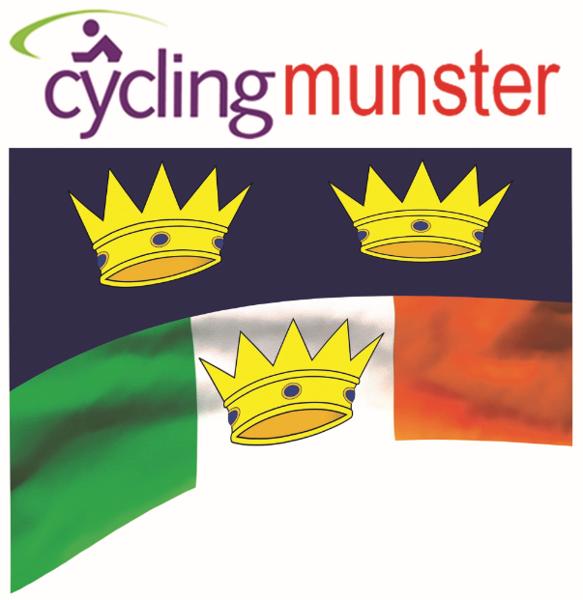
NOTICE: Munster Provincial Executive – 2019 AGM
NOTICE IS HEREBY GIVEN that the 2019 Annual General Meeting of the Munster Executive will be held at 7:00p.m on Monday the 21st of October in the
Charleville Park Hotel
The business of the Annual General Meeting shall be
A. To consider the minutes of the previous Annual General Meeting.
B. Season Reports:
- Board President: John Broderick,
- Commissaries Administrator: Brian Jordan,
- Calendar co-ordinator: Tom Shanahan
- Youth/Track: Dan Curtin
- Cyclocross: Munster Rep. John Dempsey
- Leisure: Munster Rep. Kieran Gardiner
-Women: Munster Rep. Tomás Ó Miadhacháin
- MTB: Munster Rep. Chris O’Callaghan
C. To receive and consider the annual accounts.
D. To receive and consider the financial statements of the province for the previous year.
E. To elect members of the Board,
Two of the below Board positions, having all completed their two-year term:
Board member; Mr. Seán Moriarty.
Board member; (Youth Rep) Mr. Dan Curtin
Nominations are invited for the above posts on the attached nomination form, to reach the Secretary no later than Wednesday the 16th of October.
Nominations will be accepted by email to:
cyclingmunster@hotmail.com
F. To approve the principles of the following year’s budget.
G. To transact & discuss any Special Business of the Executive.
H. To discuss & vote on motions put forward for the AGM.
Notice, motions for discussion must be received by the Secretary no later than the Wednesday the 16th of October. Please remember if you put an item forward then you must be present to discuss the item.
By order of the Board.
Mikey Moriarty
Provincial Secretary

