Registered Office: The Clock House, National Sports Campus, Snugborough Road, Blanchardstown, Dublin 15, D15 CXC2
CRO registration number: 134567
Website: www.cyclingireland.ie
Directors: Anthony Mitchell, Brendan Tallon, Noel Mulroy, Ciaran McKenna, David Smyth, Eugene Moriarty,
Gillian Mc Darby, Mícheal Concannon, Michael Mannix, Ronan McLaughlin
The Irish Cycling Federation trading as Cycling Ireland, an Irish registered company limited by guarantee.
Extraordinary General Meeting (EGM) Notice
30th October 2019

Notice is hereby given under Article 28 of the Articles of Association of the Irish Cycling Federation of the holding of an Extraordinary General Meeting on Saturday the 23rd of November at 4pm or at the conclusion of the Annual General Meeting of the Irish Cycling Federation trading as Cycling Ireland.

The meeting will consider changes to the Constitution of the Irish Cycling Federation.

Agenda:

- To approve the revised constitution of the Irish Cycling Federation

Or if item 1 is not agreed then:

- To approve the changes listed as typos and updates in the attached document
- To approve changes in the length of a term and other related issues in: definition number 13 in the list of definitions, Article 41 and Article 44 of the Articles of Association.
- To approve changes to the nomination, election and term lengths for members elected as President in Article 39 and Article 42.
- To approve changes to the selection and the term lengths for Appointed Directors and the gender bias of the board in Article 37 b, Article 37 c, Article 37 d.
- To approve changes to the definitions of Club Member and Honorary Member in Article 8 and Article 11.
- To approve changes to the time for the receipt of nominations and motions for the Annual General Meeting in Article 27 (b).
- To insert a new article on financial awards to sub committees as Article 62.

Yours sincerely,

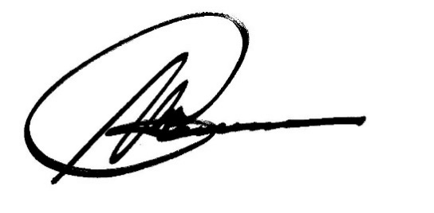
Mícheal Concannon
Company Secretary, Irish Cycling Federation t/a Cycling Ireland

